Asymmetric DCC correlation: EURUSD and NZDUSD
Method 10 / GARCH(1,1) + Cappiello-Engle-Sheppard ADCC / Alpari D1 full available history

Study setup
Logical pair: EURUSD , NZDUSD
Broker symbols: EURUSD_i , NZDUSD_i
Snapshot: 2026-11-03_majors_alpari_D1
Timeframe: D1
Matched return window: 1999-01-05 to 2026-11-02 (UTC bar dates)
Matched return count n: 7186
Dropped unfinished last bar dated 2026-11-03 UTC after a tick-volume check against the prior complete day.
EURUSD GARCH(1,1): mu=0.000011, omega=0.001157, alpha=0.036757, beta=0.959938
NZDUSD GARCH(1,1): mu=0.000003, omega=0.004886, alpha=0.040451, beta=0.950640
ADCC: a=0.022676, b=0.972641, g=0.000000, a+b+g/2=0.995317
Nested DCC (g=0): a=0.022676, b=0.972641
Negative shock: n = min(z, 0) in broker quote direction (not inverted)
Burn-in ignored in path summaries and chart: first 60 updates
Complete matched rows (Excel): EURUSD-NZDUSD_ADCC_D1.xlsx
Complete matched rows (HTML table): EURUSD-NZDUSD_ADCC_D1_data.html

Method carried forward
Asymmetric DCC extends Engle DCC with an extra term on joint negative standardised shocks. Each matched daily log return of close, ln(close_t / close_t-1), is first filtered by a constant-mean GARCH(1,1). Then z = residual / sigma and n = min(z, 0). The Cappiello-Engle-Sheppard recursion uses A = (1-a-b) Q_bar - g N_bar with N_bar = mean(n n'). Quotes are not inverted, so a negative shock is a negative log return in the broker quote. Nested symmetric DCC (g = 0) is fit on the same z path for comparison. Constraints: a,b,g >= 0 and a + b + g/2 < 1. Path summaries ignore the first 60 updates. The headline is latest ADCC rho. Pearson r is a side check only. This is not a cause, lead, or trading signal.

Results
Latest ADCC rho: 0.616207
Latest nested DCC rho: 0.616207
Post-burn-in ADCC path (n=7126): mean=0.533408, median=0.558051, min=0.031357, max=0.776057, std=0.142468
Share of post-burn-in days with |rho| >= 0.4: 82.28%; |rho| >= 0.7: 8.55%
Same-sample Pearson r: 0.549808
ADCC minus r: 0.066399
ADCC minus nested DCC: -0.000000

Conclusion
Over 7186 matched daily log-return rows for EURUSD and NZDUSD (broker quote directions unchanged), latest ADCC rho is 0.6162 (positive, moderate conditional linear link in this sample) with fitted a=0.0227, b=0.9726, g=0.0000. Nested symmetric DCC latest rho is 0.6162 (ADCC minus DCC = -0.0000). After a 60-day burn-in, path mean is 0.5334 and std is 0.1425. Same-sample Pearson r is 0.5498 (ADCC minus r = 0.0664). This does not establish cause, lead-lag, or a lasting trading rule.

Charts
Daily closes

Daily log returns
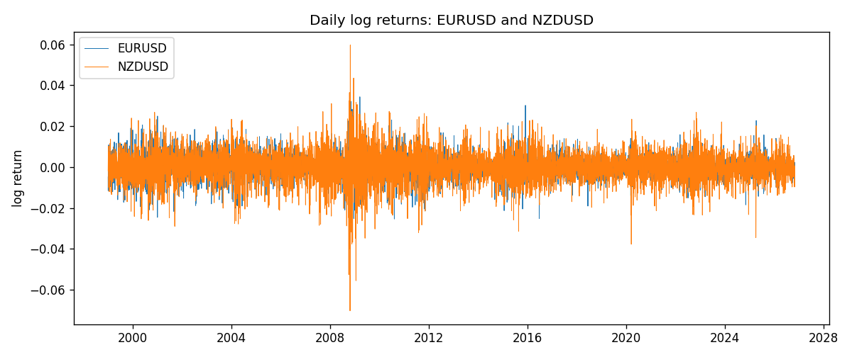
ADCC rho path with nested DCC and Pearson r
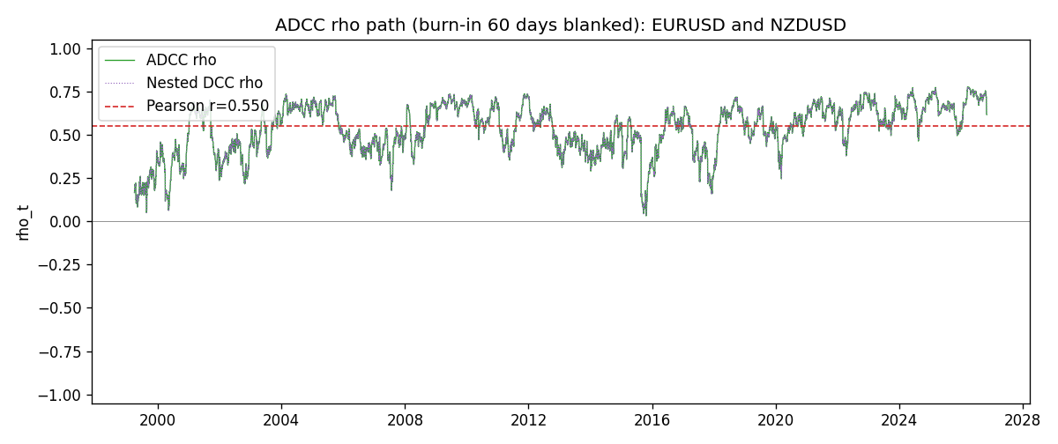

Data report
Every matched row that entered the ADCC recursion is stored in the sibling Excel workbook named EURUSD-NZDUSD_ADCC_D1.xlsx. Embedding all rows as a Word table is impractical at this length; the Word file holds the column list, column summaries, and the first and last 15 matched rows.
Columns: time, EURUSD_open, NZDUSD_open, EURUSD_high, NZDUSD_high, EURUSD_low, NZDUSD_low, EURUSD_close, NZDUSD_close, EURUSD_tick_volume, NZDUSD_tick_volume, EURUSD_spread, NZDUSD_spread, EURUSD_real_volume, NZDUSD_real_volume, EURUSD_log_return, NZDUSD_log_return, EURUSD_sigma, NZDUSD_sigma, EURUSD_z, NZDUSD_z, EURUSD_n, NZDUSD_n, q11, q22, q12, rho_adcc, rho_dcc
Column summaries (matched calculation rows)
column | count | mean | std | min | 25% | 50% | 75% | max
EURUSD_open | 7186 | 1.181357 | 0.15085833 | 0.8272 | 1.086165 | 1.16609 | 1.2939475 | 1.5995
NZDUSD_open | 7186 | 0.65641776 | 0.10819833 | 0.3913 | 0.59134 | 0.6684 | 0.7249075 | 0.88218
EURUSD_high | 7186 | 1.1864878 | 0.15145386 | 0.8326 | 1.09024 | 1.17121 | 1.2993075 | 1.6038
NZDUSD_high | 7186 | 0.66033433 | 0.10869188 | 0.3961 | 0.59475 | 0.67202 | 0.72936 | 0.88421
EURUSD_low | 7186 | 1.1763494 | 0.15017707 | 0.8227 | 1.082045 | 1.162475 | 1.2884175 | 1.5865
NZDUSD_low | 7186 | 0.65273031 | 0.10779283 | 0.3897 | 0.5880725 | 0.664185 | 0.720965 | 0.87988
EURUSD_close | 7186 | 1.1813978 | 0.15082738 | 0.8267 | 1.0860425 | 1.16602 | 1.2939725 | 1.5997
NZDUSD_close | 7186 | 0.65649194 | 0.10819527 | 0.3907 | 0.59159 | 0.66842 | 0.725015 | 0.8822
EURUSD_tick_volume | 7186 | 103205.25 | 173535.32 | 218 | 9413.25 | 52774.5 | 99579.75 | 1471626
NZDUSD_tick_volume | 7186 | 68709.014 | 123134.25 | 16 | 5585.5 | 33893.5 | 58510.5 | 1127682
EURUSD_spread | 7186 | 19.350682 | 16.562781 | 0 | 8 | 12 | 27.5 | 50
NZDUSD_spread | 7186 | 30.284303 | 25.649992 | 0 | 9 | 17 | 47.5 | 80
EURUSD_real_volume | 7186 | 4.0330482e+10 | 1.6691688e+11 | 0 | 0 | 0 | 0 | 3.6149665e+12
NZDUSD_real_volume | 7186 | 1.6701379e+10 | 8.497804e+10 | 0 | 0 | 0 | 0 | 2.705649e+12
EURUSD_log_return | 7186 | -4.99e-06 | 0.00579654 | -0.03123819 | -0.00323792 | 0 | 0.00325328 | 0.03433183
NZDUSD_log_return | 7186 | 9.3e-06 | 0.0076423 | -0.07027433 | -0.00425367 | 0.00022883 | 0.00457975 | 0.05966839
EURUSD_sigma | 7186 | 0.00556297 | 0.00169657 | 0.00258126 | 0.00432043 | 0.00537998 | 0.00650387 | 0.01459061
NZDUSD_sigma | 7186 | 0.00728654 | 0.00216629 | 0.0043898 | 0.00596147 | 0.0067057 | 0.00804175 | 0.02518945
EURUSD_z | 7186 | -0.0031336 | 1.0000309 | -5.7783744 | -0.62073529 | -0.0018179 | 0.60937266 | 5.2070015
NZDUSD_z | 7186 | -0.00211892 | 1.0000727 | -5.6219453 | -0.62967038 | 0.03272736 | 0.64628381 | 4.2207221
EURUSD_n | 7186 | -0.38690054 | 0.59318645 | -5.7783744 | -0.62073529 | -0.0018179 | 0 | 0
NZDUSD_n | 7186 | -0.38933332 | 0.6154744 | -5.6219453 | -0.62967038 | 0 | 0 | 0
q11 | 7186 | 1.000791 | 0.1684501 | 0.60231996 | 0.88669849 | 0.98670646 | 1.095187 | 1.9460447
q22 | 7186 | 1.0013059 | 0.17127811 | 0.65726272 | 0.88492518 | 0.97174139 | 1.0804809 | 2.2068768
q12 | 7186 | 0.53101564 | 0.17136197 | 0.03535704 | 0.41248424 | 0.53231757 | 0.64733163 | 1.3150704
rho_adcc | 7186 | 0.53116586 | 0.14433569 | 0.03135664 | 0.43640694 | 0.55636304 | 0.64936479 | 0.77605661
rho_dcc | 7186 | 0.53116586 | 0.14433567 | 0.03135682 | 0.43640693 | 0.55636304 | 0.64936479 | 0.77605651
First 15 matched rows (selected columns)
time | EURUSD_log_return | NZDUSD_log_return | EURUSD_z | NZDUSD_z | EURUSD_n | NZDUSD_n | q11 | q22 | q12 | rho_adcc | rho_dcc
1999-01-05 | -0.0048360507 | -0.0018597736 | -0.73678681 | -0.31667614 | -0.73678681 | -0.31667614 | 1 | 1 | 0.53073113 | 0.53073113 | 0.53073113
1999-01-06 | -0.011547966 | 0.0020455609 | -1.7726164 | 0.35280252 | -1.7726164 | 0 | 0.98963381 | 0.97959809 | 0.52398712 | 0.53218102 | 0.53218102
1999-01-07 | 0.0076280636 | 0.0062963171 | 1.1250309 | 1.1035373 | 0 | 0 | 1.0384931 | 0.96030278 | 0.49795564 | 0.49863729 | 0.49863733
1999-01-08 | -0.010902799 | -0.00055396548 | -1.604678 | -0.096933994 | -1.604678 | -0.096933994 | 1.0434649 | 0.96632754 | 0.51496999 | 0.51283875 | 0.51283877
1999-01-11 | -0.007103287 | 0.010290425 | -1.0173786 | 1.8219961 | -1.0173786 | 0 | 1.0779901 | 0.94478591 | 0.50689356 | 0.50227629 | 0.50227633
1999-01-12 | 0.0045103728 | -0.0053157489 | 0.6433747 | -0.8980456 | 0 | -0.8980456 | 1.0766514 | 0.99889718 | 0.45347743 | 0.43727809 | 0.4372782
1999-01-13 | 0.010845346 | -0.0099742238 | 1.5668924 | -1.6869843 | 0 | -1.6869843 | 1.0612647 | 0.99453924 | 0.43045447 | 0.41899072 | 0.41899085
1999-01-14 | 0 | -0.00018564931 | -0.0015176869 | -0.030689175 | -0.0015176869 | -0.030689175 | 1.0925855 | 1.0365465 | 0.36122327 | 0.33943265 | 0.33943285
1999-01-15 | -0.010153245 | -0.00074294208 | -1.4605592 | -0.12364316 | -1.4605592 | -0.12364316 | 1.0673766 | 1.0128921 | 0.35382703 | 0.3402911 | 0.34029131
1999-01-18 | 0.0036256946 | -0.0018597736 | 0.50919339 | -0.31437655 | 0 | -0.31437655 | 1.0912304 | 0.99021009 | 0.3507271 | 0.33740183 | 0.33740203
1999-01-19 | -0.00017235436 | 0.0018597736 | -0.026166245 | 0.31842742 | -0.026166245 | 0 | 1.0719378 | 0.97004311 | 0.33998704 | 0.33341263 | 0.33341283
1999-01-20 | -0.0031939256 | 0.0040793678 | -0.46679728 | 0.71012005 | -0.46679728 | 0 | 1.0473093 | 0.950486 | 0.3329818 | 0.33374146 | 0.33374166
1999-01-21 | 0.0030215416 | 0.0040627941 | 0.44518902 | 0.71228482 | 0 | 0 | 1.0282801 | 0.94059951 | 0.31884049 | 0.32420177 | 0.32420198
1999-01-22 | -0.0012075213 | -0.012051689 | -0.18293036 | -2.1296855 | -0.18293036 | -2.1296855 | 1.0093247 | 0.93105332 | 0.31979331 | 0.32988811 | 0.32988831
1999-01-25 | -0.0030251979 | -0.0035504102 | -0.4643489 | -0.58556195 | -0.4643489 | -0.58556195 | 0.98715242 | 1.0131118 | 0.32236368 | 0.32234824 | 0.32234845
Last 15 matched rows (selected columns)
time | EURUSD_log_return | NZDUSD_log_return | EURUSD_z | NZDUSD_z | EURUSD_n | NZDUSD_n | q11 | q22 | q12 | rho_adcc | rho_dcc
2026-10-13 | 0.0037402957 | 0.0047326165 | 1.079413 | 0.96003183 | 0 | 0 | 0.9082807 | 0.7406016 | 0.60468056 | 0.73726504 | 0.73726504
2026-10-14 | -0.0037582255 | -0.0037306483 | -1.0841036 | -0.7548159 | -1.0841036 | -0.7548159 | 0.91453456 | 0.74592202 | 0.61412098 | 0.74354483 | 0.74354482
2026-10-15 | 0.0056053107 | 0.0047634855 | 1.5990706 | 0.96549772 | 0 | 0 | 0.92084745 | 0.7431169 | 0.6183604 | 0.74751387 | 0.74751385
2026-10-16 | 0.0017724895 | 0.0057501001 | 0.48831085 | 1.1607051 | 0 | 0 | 0.95832 | 0.74860716 | 0.63893749 | 0.75435558 | 0.75435556
2026-10-19 | -0.0025394633 | 0.0018917133 | -0.71492356 | 0.37676548 | -0.71492356 | 0 | 0.9421914 | 0.76335888 | 0.63679464 | 0.75087121 | 0.7508712
2026-10-20 | 0.0023881672 | 0.0037199341 | 0.67057022 | 0.75058276 | 0 | 0 | 0.93268706 | 0.75037606 | 0.61575009 | 0.73603255 | 0.73603256
2026-10-21 | -0.00032046717 | 0.0030923331 | -0.094104611 | 0.62593329 | -0.094104611 | 0 | 0.92204928 | 0.74730457 | 0.61280246 | 0.73823497 | 0.73823497
2026-10-22 | -0.0015949606 | -0.0033035227 | -0.46328816 | -0.67447006 | -0.46328816 | -0.67447006 | 0.90170679 | 0.74042634 | 0.59718657 | 0.73086377 | 0.73086378
2026-10-23 | -0.001338521 | 0.0030929853 | -0.39376299 | 0.63369694 | -0.39376299 | 0 | 0.88658711 | 0.73516754 | 0.59041924 | 0.73131863 | 0.73131864
2026-10-26 | -0.0022706559 | -0.0028993932 | -0.67410045 | -0.59898111 | -0.67410045 | -0.59898111 | 0.8705299 | 0.72884311 | 0.57109317 | 0.71696523 | 0.71696527
2026-10-27 | -0.004152342 | -0.00026399852 | -1.2383259 | -0.055483126 | -1.2383259 | -0.055483126 | 0.86170031 | 0.72172134 | 0.56711003 | 0.71912507 | 0.7191251
2026-10-28 | 0.0022262927 | -0.0097283914 | 0.65043829 | -2.0516469 | 0 | -2.0516469 | 0.87758054 | 0.70672858 | 0.5556379 | 0.70554065 | 0.7055407
2026-10-29 | 0.0022571351 | 0.00062190714 | 0.66434034 | 0.12207842 | 0 | 0 | 0.86784736 | 0.78752504 | 0.5126613 | 0.62012134 | 0.6201215
2026-10-30 | -0.0011458446 | 0.00019537668 | -0.34442698 | 0.038530329 | -0.34442698 | 0 | 0.85879493 | 0.7710001 | 0.5029599 | 0.61810379 | 0.61810394
2026-11-02 | 0.002120569 | -0.0025962955 | 0.63642551 | -0.52836374 | 0 | -0.52836374 | 0.84267224 | 0.75462299 | 0.49138393 | 0.61620694 | 0.6162071

